<https://www.oracle.com/in/java/technologies/javase/jdk11-archive-downloads.html>

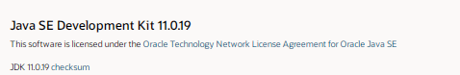

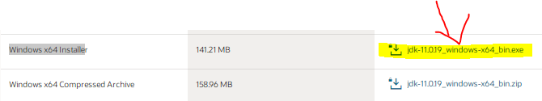

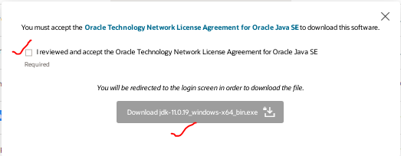

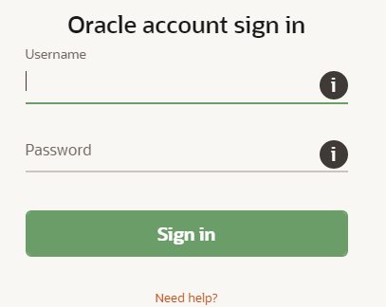

Enter login details to download JDK file

After valid login entry setup file download into local PC

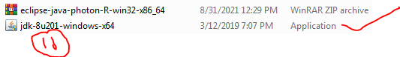

Open the executable file which you have just downloaded and follow the steps.

Use double click to install java into your pc

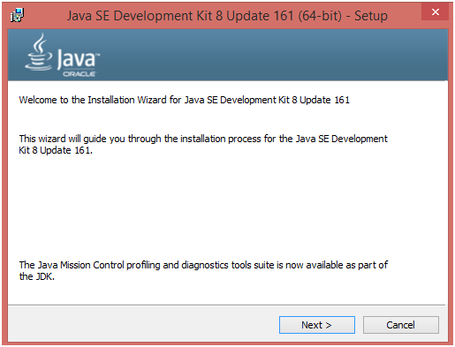

Click **Next** to continue

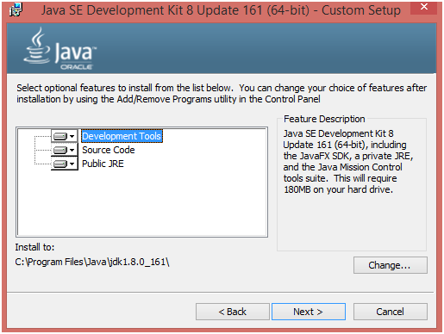

Just Choose Development Tools and click Next.

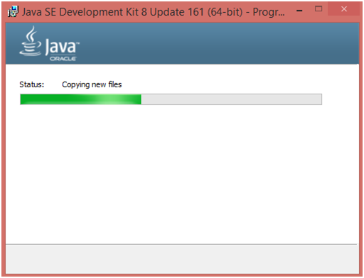

Set up is being ready.

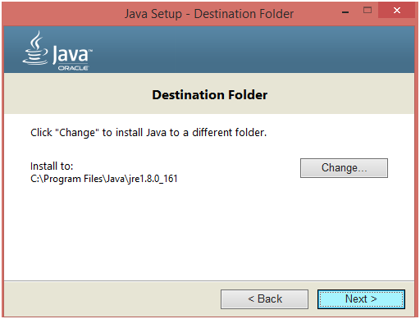

Choose the Destination folder in which you want to install JDK. Click Next to continue with the installation.

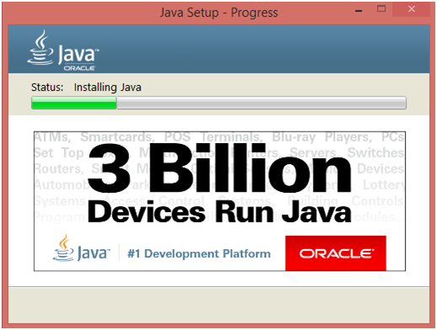

Set up is installing Java to the computer.

# JavaFX Install JDK 5

# Click on close button to Finish Java Installation

# How to confirm java installation:🡪

# Open Command Window and type below syntax to check java availability

# 

# Note:🡪 there is a chance multiple java versions installed in computer. In order to

# Confirm which java version compile your programs we need to set up environment variable

# Add to the PATH on Windows 10

* Open the Start Search, type in “env”, and choose “Edit the system environment variables”:
* 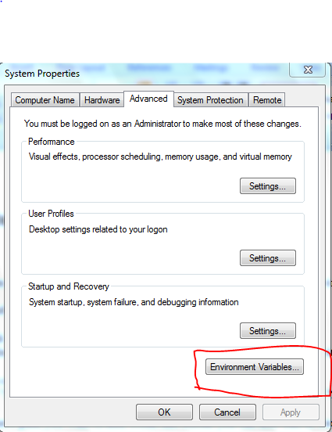
* Click the “Environment Variables…” button.
* 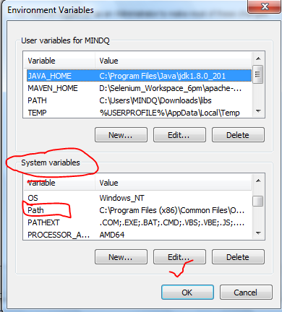
* Under the “System Variables” section (the lower half), find the row with “Path” in the first column, and click edit.

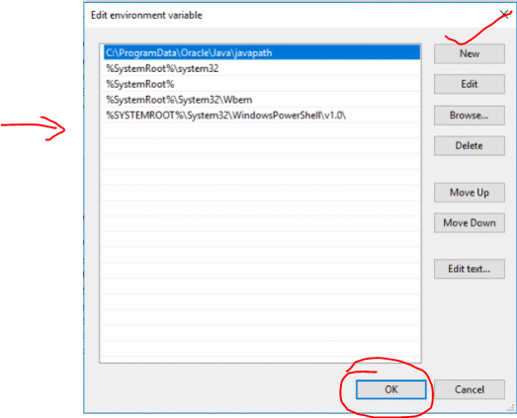

The “Edit environment variable” UI will appear. Here, you can click “New” and type in the new path you want to add. From this screen you can also edit or reorder them.

Dismiss all of the dialogs by choosing “OK”. Your changes are saved

C:\Program Files\Java\jdk1.8.0_201\bin

Download Eclipse:🡪

<https://www.eclipse.org/downloads/packages/release/2022-03/r>

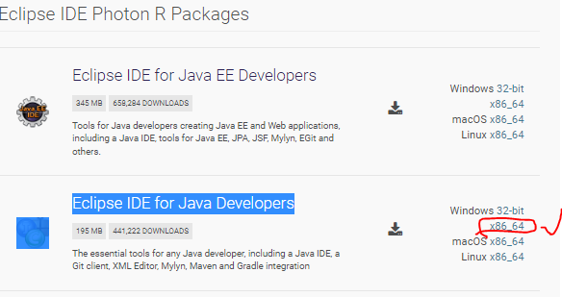

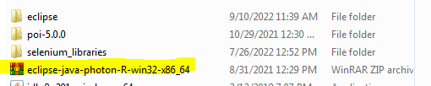

* File download in Zip format file
* Save Eclipse into backup folder
* Right click on Eclipse Zip file and Select Extract All
* Select Required Folder click on ok button
* System unzip all files into eclipse folder



* Open Eclipse folder to see all properties

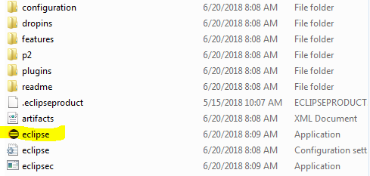

Click on Eclipse Ball icon button to open Eclipse Editor…